**BX2184: SUSTAINABLE MARKETING**

**ASSESSMENT TASK 2**  **COLLEGE OF BUSINESS, LAW & GOVERNANCE**

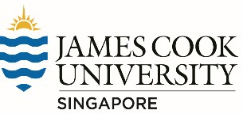**GROUP TASK COVER SHEET**

|  |  |  |  |  |  |  |  |  |  |
| --- | --- | --- | --- | --- | --- | --- | --- | --- | --- |
| *Students*  *Please sign, date and attach cover sheet to front of written assessment task OR*  *submit as a separate document for non-written assessment task.*  *A cover sheet is to be completed for each assessment task.* | | | | | | | | | |
| **SUBJECT CODE** | BX2184 | | | | | | | | |
| **STUDENT FAMILY NAME** | **Student Given Name** | **JCU Student Number** | | | | | | | |
| i. Tran | Le Binh | 1 | 3 | 4 | 7 | 6 | 1 | 1 | 2 |
| ii. Nubtong | Kaoketkorn | 1 | 3 | 1 | 2 | 2 | 1 | 2 | 2 |
| iii. Ong | Wei Lian | 1 | 2 | 9 | 1 | 3 | 2 | 0 | 8 |
| **ASSESSMENT TITLE** | Sustainable Marketing Case Study | | | | | | | | |
| **DUE DATE** | 17 Jan 2018 | | | | | | | | |
| **LECTURER NAME** | Desmond Chow | | | | | | | | |
| **TUTOR NAME** | Desmond Chow | | | | | | | | |
| **Student Declaration**   1. This assignment is our original work and no part has been copied/ reproduced from any other person’s work or from any other source, except where acknowledgement has been made (see *Learning, Teaching and Assessment Policy 5.1*). 2. This work has not been submitted for any other course/subject (see *Learning, Teaching and Assessment Policy 5.9*). 3. This assignment has not been written for us. 4. We hold a copy of this assignment and can produce a copy if requested. 5. This work may be used for the purposes of moderation and identifying plagiarism. 6. We give permission for a copy of this marked assignment to be retained by the College for benchmarking and course review and accreditation purposes.   [Learning, Teaching and Assessment Policy](http://www.jcu.edu.au/policy/allitoz/JCU_076643.html) 5.1. A student who submits work containing plagiarised material for assessment will be subject to the provisions of the [Student Academic Misconduct Requirements.](http://www.jcu.edu.au/policy/allitoz/JCUDEV_005375.html)  **Note definition of plagiarism and self plagiarism in Learning, Teaching and Assessment Policy:**  **Plagiarism:** reproduction without acknowledgement of another person’s words, work or expressed thoughts from any source. The definition of words, works and thoughts includes such representations as diagrams, drawings, sketches, pictures, objects, text, lecture hand-outs, artistic works and other such expressions of ideas, but hereafter the term ‘work’ is used to embrace all of these. Plagiarism comprises not only direct copying of aspects of another person’s work but also the reproduction, even if slightly rewritten or adapted, of someone else’s ideas. In both cases, someone else’s work is presented as the student’s own. Under the Australian Copyright Act 1968 a copyright owner can take legal action in the courts against a party who has infringed their copyright.  **Self Plagiarism:** theuse of one’s own previously assessed material being resubmitted without acknowledgement or citing of the original. | | | | | | | | | |
| **Student signature(s)**   1. Tran Le Binh Submission date 17/ 1/ 2018 2. Nubtong Kaoketkorn Submission date 17/ 1/ 2018 3. Ong Wei Lian Submission date 17/ 1/ 2018 | | | | | | | | | |

**TABLE OF CONTENT**

1. Executive Summary 3

2. Introduction 4

3. Sustainable efforts 5

4. Triple bottom line 5

4.1. Environmental 5

4.2. Economic 5

4.3. Social 5

5. The organization’s current marketing strategy (4P’s) 6

5.1. Place 6

5.2. Promotion 6

5.3. Product 6

5.4. Price 7

6. SWOT analysis 7

6.1. Strength 7

6.2. Weaknesses 8

6.3. Opportunities 8

6.4. Threats 8

7. Competitive analysis 8

8. The outcome of sustainable marketing efforts 11

9. The drawback with the public and the issues that company is genuine about sustainability 11

10. Recommendation 12

11. Conclusion 13

**APPENDIX**

**REFERENCES**

# Executive Summary

L’Oréal is one of the biggest cosmetic company in the world which applies maximum sustainable efforts on their products. The purpose of this report is to determine the sustainable efforts, SWOT analysis, and competitor analysis of L’Oréal Company with recommendations. First part of this report reviews company background, history, and information. In addition, it introduces the L’Oréal current sustainable efforts including ecological, water and carbon footprints. The analysis part contains company triple bottom line that focuses on environmental, social, and economic aspects. Followed by marketing strategy using 4P’s and SWOT analysis to point out competitor’s information. After competitive analysis, the outcome of sustainable marketing efforts shows a good brand image for L’Oréal to examines some drawback of any issues. Lastly, three recommendations are provided to further improve the sustainable efforts.

# Introduction

L’Oréal can be considered as one of the largest cosmetic company in the world which was first officially established in 1909 as a small company and provided hair dye by Eugène Schueller a French chemist. Currently, the company has manufactured thousands of individual products in beauty and fragrance sectors as it has owned 500 well-known brands share in the beauty care industry producer. The developed and provided products by L’Oréal are personal care products for both male and female. Such as skin care, makeup, styling, hair care and hair color (L'Oreal, n.d.). Now, most of their products are environmental friendly since it has set up its sustainable commitments. It has been turned itself to be more sustainability and focused on CSR in the 1980s. Moreover, it has hold a leadership in developing advanced product evaluation methods since then. The company target market seems to be both male and female between middle class to high class age from 15 to 50 year olds who tend to take care of themselves especially their appearance.

As it is an international company, it has expanded supply chain and its market presence to be in almost every country in the world. In 2017, L’Oréal group is worth $107 Billion and has a sale at $28.58 billion in the same year with 89,331 employees. The current chief Executive Officer is Jean-Paul Agon (Forbes, n.d.). In term of sustainability, L’Oréal have been attempting to maintain its leadership in term of innovation and sustainability for all the aspects as it is the first company to be capable to cut down environmental footprint in all of their businesses sector. Plus, L’Oréal focuses on doing CSR regrading to giving out the career inspiration in science and career opportunity in beauty industry for female. Moreover, it has also done some sustainability activities for environmental aspect to its products that it produces all of its products to be most harmless to environment since the producing process to disposal process (L'Oréal, n.d.). Moreover, these are the reasons why L’Oréal take sustainability seriously. First, I want to improves its products profile on environmental and social. Next, it has an objective to present a brand’s sustainability efforts to its customers. Lastly, it wants to communicate with its customer of how the company positively contribute to environmental efforts.

# Sustainable efforts

L’Oréal was the first proved that it enables to cut their environmental footprint in all businesses sector. It always attempts itself to be a sustainability leader by focusing on triple bottom line and all type of footprints “Ecological, Water and Carbon footprints. However, L’Oréal is the most profitable company in the industry and it has increased its production volume by 26% between 2005 to 2016. It has reduced its greenhouse gas emissions by 67% which is Ecological footprints. One of the current sustainable efforts is that it tackles each stage of its product’s development from production sector to transportation sector. For example, running on its manufacture by using renewable energy, using less plastic packaging or use more biodegradable materials if possible and using electric vehicles to reduce carbon footprint and tightening transit routes which relate to engagement with consumer’s theory from Waitrose’s sustainable business network and Sustainable packaging options from eliminate stage (Anzilotti, 2017).

# Triple bottom line

## Environmental

In term of environment dimension, L’Oréal set up its sustainable objectives and measurement of the company’s environmental dimension by using producing sustainability, innovating sustainability and living sustainability.

Look at appendix 1,2 &3: figure of what L’Oréal have achieved in 2016 and its objectives by 2020.

According to the sustainable business network, L’Oréal has started to used biodegradable material to produce its shampoo which is harmless to the environment and be much more convenient for customer who want to start on sustainable goal as it is relative to Conflict of Interest in term of Convenience and availability. Based on its ongoing action and its future objective. L’Oréal can be considered to be sustainable for environmental aspect based on engagement with customer’s strategy (Martin & Schouten, 2014).

## Economic

As 60% of the main minerals “Mica” minerals that use in the production process is mined in India. L’Oréal decided to establish its own subsidiary and a manufacturing plant in Pune and its largest distribution channel there in India. So, L’Oréal will reduce the emission footprint of the material transportation. This action links to One Planet Living Initiative theory in term of Sustainable transport & Local and sustainable materials. Moreover, its sale has an increase of 6.4%, because, customers are concerned more about environment (Martin & Schouten, 2014).

## Social

One of the L’Oréal objective is supporting society and doing SCR, it has done many supporting campaign to India society. Such as provide a job opportunities to local people by training 300,000 hairdressers of how to use L’Oréal products and hair salon skills. (Mbaskool, n.d.). On the other hand, L’Oréal also have set up its objectives for 2016. Look at appendix 4, there are the sustainable of L’Oréal for communities, suppliers and employees.

# The organization’s current marketing strategy (4P’s)

### Place

L’Oréal makes their products available for their customer worldwide. It has a vast distribution networks which lead L’Oréal to have a strong market presence. These a few years, L’Oréal has been expensed its marketplace into 130 countries in 5 continents around the world. Customers can find its product available in almost department stores, retail outlets and even e-commerce websites. As a purpose of reducing carbon footprint, L’Oréal has built its own subsidiary and a manufacturing plant in India as well as it has created the most efficient distribution channel. Since, 60% of the minerals usage in producing L’Oréal’s product is mined in India where company enable to reduce transportation costs and transportation emission footprint. These actions relate to economical & environmental responsibility aspects, Engagement with suppliers from Waitrose’s sustainable business network and One Planet Living Initiative theory in term of Sustainable transport & Local and sustainable materials (Mbaskool, n.d.).

So, L’Oréal has provided the career opportunity to local people by training more than 30,000 hairdressers in 300 salons in the use of its products in India (Mbaskool, n.d.). As L’Oréal have supported Indian citizens, this action can relate to sustainable social aspect.

### Promotion

L’Oréal has done different kind of promotion at different level in many countries. It also has a strong message to attract its customers with its advertising slogan “Because we’re Worth It”. Moreover, L’Oréal have been using celebrities and attractive models to be their brand ambassadors for different campaigns all over the world. The company has a commitment to do various CSR campaigns. Such as “Young Women in Science” which encourage young women to follow their career dream in science industry and “Beautiful Beginnings” which has objective to support uneducated women to start their own salon or be a part of existing beauty salons (Mbaskool, n.d.). These campaigns can be considered as CSR in term of social responsibility and economical for triple bottom.

### Product

L’Oréal is a global cosmetic company which comes out with several series and different types of products include cosmetic products, daily products and beauty care products. Basically, L’Oréal products can be categorized into 4 divisions. The first division is luxury products including Yves Saint Laurent and Ralph Lauren. The second division is consumer products including L’Oréal Paris, Garnier and Maybelline. The third division is active cosmetics including Vichy and Sanoflore. Lastly, the fourth division is professional products which including Kerastase and Matrix (Marketing mix, 2002). All these products are innovated and created based on customers’ satisfaction and needs. The products are designed with eco-friendly concept and sustainable methods (Marketing 91, 2004). Furthermore, the products have been tested according to the international testing standards without harming any animals during the process (Scribt, 2012).

### Price

As one of the leading global brands, L’Oréal has distributed products all over the world and the company earns huge profits. Although, L’Oréal is a luxury brand, its’ product price is considered to be affordable for its customers from low to high income. Moreover, the company provides premium price for the customers. Therefore, the customers are able to buy its products in supermarkets and cosmetic stores. L’Oréal also uses value based price strategies for most of the products. So, L’Oréal’s products will be more affordable to its customer (Investopedia, 2010). L’Oréal also has different price levels for different geography. Then, people with low income will have the ability to purchase L’Oréal products (Matrix, 2011).

# SWOT analysis

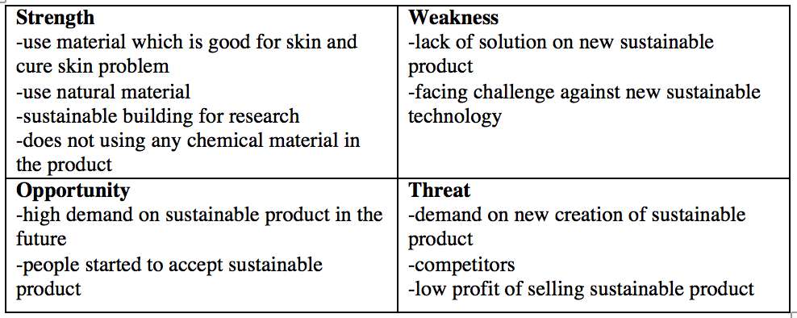

#### Strength

One of the biggest strengths of L’Oréal in term of sustainable is that its use natural material to produce its products. Nowadays, people’s preference is getting more on sustainable products, which is one of the biggest strengths of L’Oréal because the product does not contain any chemical materials and had been replaced by natural and sustainable materials. The materials also benefit the skin and the effect of skin problems, comparing to normal cosmetic products. Meanwhile, L’Oréal has also built sustainable buildings for their researchers to do their research under a sustainable environment (Eco-design, 2012).

#### Weaknesses

The weakness that L’Oréal sustainable development facing is the lack of creation and innovation on new sustainable products. To solve these problems, the researchers have to experiences more to collect new information. Thus, its researchers will be able to come up with the new sustainable products. Another weakness is that lacking of new sustainable technology. Nowadays, there are many cosmetic products that are replaced by new sustainable technology, which is a huge challenge for L’Oréal. To solve this challenge, L’Oréal has to be more creative for sustainable technology and product.

#### Opportunities

As people tend to be more sustainable in their lifestyle. Plus, demands on sustainable products are getting higher continuously. People believe that using sustainable product can improve the environmental situation like global warming. Customers are willing to accept and try more sustainable products. However, it is much costly compare to non-sustainable product.

#### Threats

High demand on new innovative sustainable product can be both opportunity and threat for L’Oréal. The demand on new sustainable product is challenge for L’Oréal sustainable developers and its team seems to handle the situations not well enough. Hence in the long runs, there is an invisible threat toward L’Oréal due to its competitors such as Estee Lauder, the Body Shop and Nivea. Therefore, these companies might also develop sustainable products. Since the producing cost of sustainable product is higher than non-sustainable products, L’Oréal’s incomes might drop in the long run.

# Competitive analysis

L’Oréal basically provides cosmetic and haircare products, which the price depends on many factors such as quality and materials and its value-based price strategy (Quick Guide, 2008).

Look at the table below to see the comparison of L’Oréal and its competitors in term of pricing

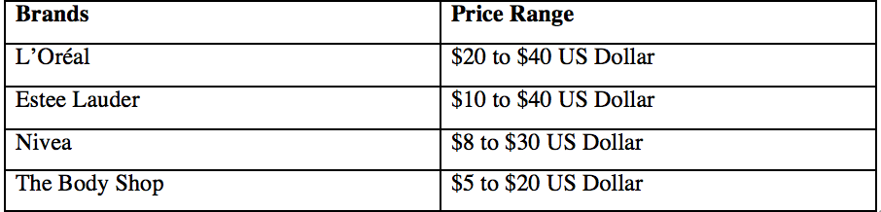

Table 1: Price Comparisons of L’Oréal and its competitors

According to table above, the entire competitors have cheaper price range compare to L’Oréal products. Since, L’Oréal is a global and high branding product, its products’ price is slightly more expensive than its competitors. The main differentiation between L’Oréal and its competitors are the different level of sustainable impacts toward the environment. L’Oréal has given a huge effort on sustainable products which by creating a better and healthier society (L’Oréal Sustainable, 24010). The three key topics for L’Oréal sustainable development are climate protection, sustainable water management and the fight against deforestation (L’Oréal Sustainable, 2010).

There are 3 companies competing with L’Oréal like Body Shop, Estee Lauder and Nivea. These companies conduce distinct sustainable activities in terms of triple bottom line such as economic, social and environmental. To be more specific, the below table will indicate the efforts compared with 3 competitors.

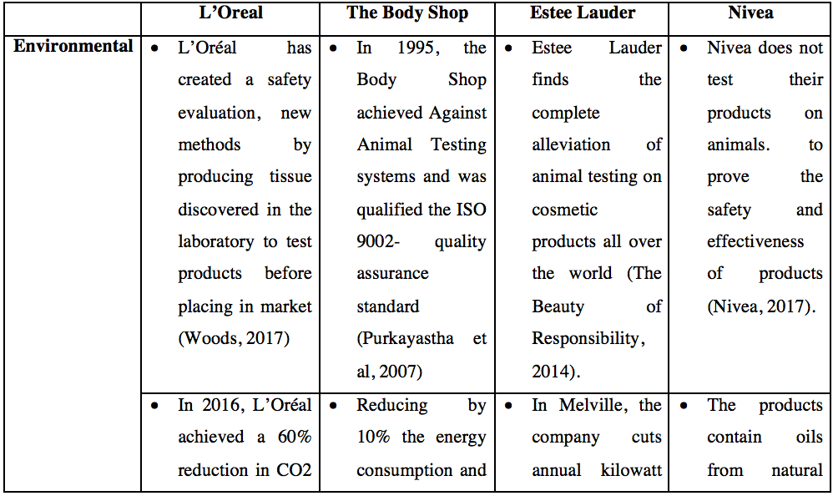

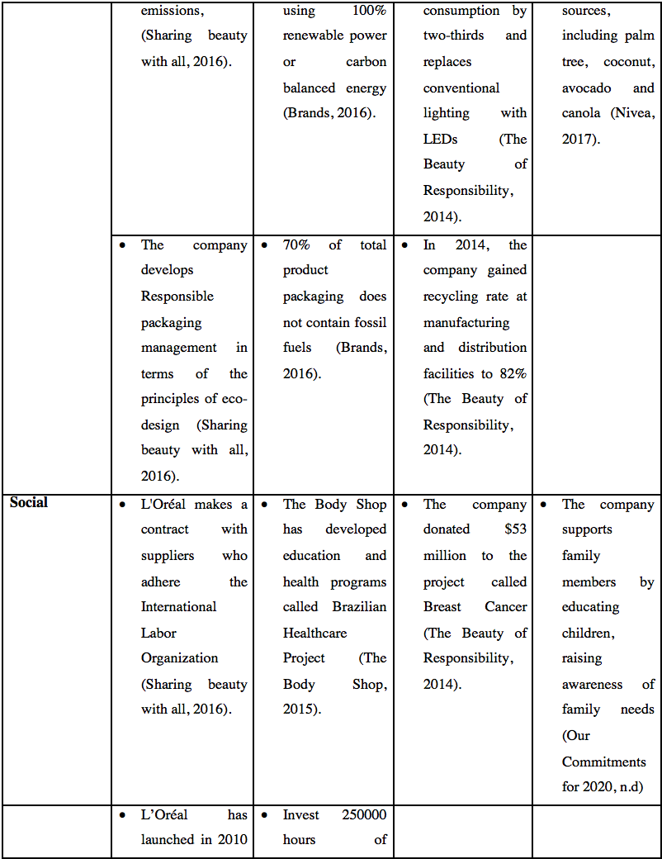

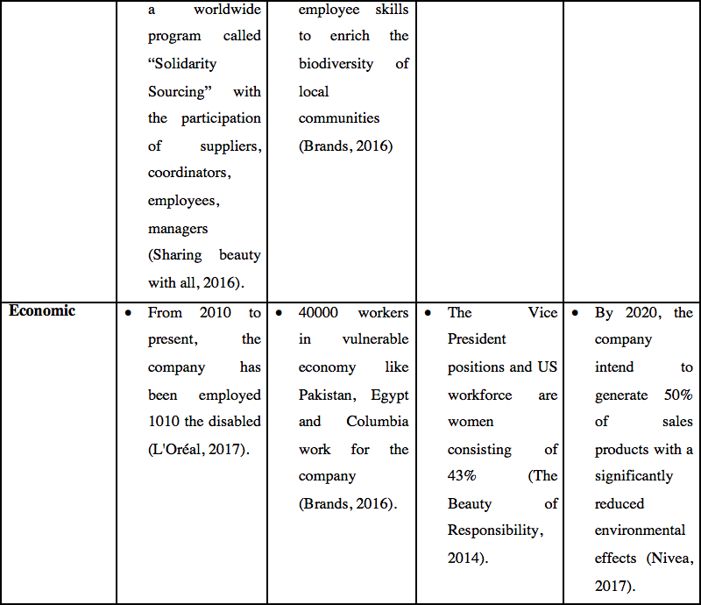

Table 2: The Comparison of Sustainable Efforts

# The outcome of sustainable marketing efforts

Sustainable marketing efforts are the activity engaging in developing, communicating and transmitting value to consumers where both natural and human’s capital are improved or conversed. Marketing efforts must be conducted in sustainable way so that all the marketing processes are environmentally and socially suitable (Martin & Schouten, 2014). L’Oréal achieves some successes in sustainable marketing efforts. Through the comparison in sustainable marketing activities, L’Oréal obtains some recognitions such as in 2017, L’Oréal USA achieved the U.S Environmental Protection Agency (EPA) awards through adapting the requirement of using Green Power Partner of the year, Sustained Excellence in Green Power, Direct Project Engagement, Excellence in Green Power Use and Green Power Community of the Year (L’Oréal USA, 2017). Moreover, The Carbon Disclosure Project (CDP) recognized that L’Oréal gains highest level of performance like climate protection, sustainable water management and fight against deforestation (Newswire, 2017).

# The drawback with the public and the issues that company is genuine about sustainability

On the one hand, L’Oréal also violates two elements of the triple bottom line. First environmental factor, L’Oréal commits to stop testing products on animal. However, Chinese legislation of testing product on animal is legal and it is controlled by Chinese government. Therefore, there are some products which test on animals (Animals are not ours, n.d).

Secondly social factor, L’Oréal has greenwashing. Greenwashing refers to the activity of conducting false or exaggerating claims to anticipate a sustainable scenario than is warranted by actual situation (Martin & Schouten, 2014). There is a sin of no proof which makes a claim with no verifiable certification (Spaulding, 2009). In 2014, L’Oréal stated that their two products called Lancôme Génifique and L’Oréal Paris Youth Code skincare contain “clinically proven" to "boost genes" and give "visibly younger skin in just seven days” (Kieler, 2014). However, according to FTC – Federal Trade Commission, the organization investigated that this claim had no scientific evidence (Heilpern, 2016). Therefore, it affects the community belief.

Moreover, L’Oréal also makes a mistake when using endorsement executional techniques. The creative executional techniques in terms of endorsement refers to the technique where the celebrity advertise the products (Belchet et al, 2014). In 2009, L’Oréal used the Brand Ambassador named Munroe Bergdorf to advertise their products. However, she raised racial discrimination for Arab and Asian women selling L’Oréal shampoo (Iqbal, 2017).

L’Oréal is one of the top producing mica countries in the world. Mica is the mineral that is used to demolish beauty products such as blusher, eye shadow, lipstick and foundation, the paints (Bengtsen, 2016). Surprisingly, the labor are children who mine the mica in Jharkand and Bihar. It is discovered that mica is utilized for many cosmetic products developed by the company (L'Oréal,2017). UNICEF reported that there are 13% children aged between 5 to 14 years old made up in child labor (UNICEF, 2017). Hence, the company should take some actions to decrease child labor in India.

# Recommendation

Place element from 4Ps which mentioned that L’Oréal has own subsidiary and a manufacturing plant in Pune India. The company purchases the raw ingredient “Mica” which is the foundation for many cosmetic products (Loreal, 2017). Furthermore, 60% of those minerals which the company purchase is mined in India. As a result, L’Oréal has been accused for using child labor indirectly. Since, the Mica and other minerals have a high demand in the cosmetic production. There is a high chance for L’Oréal to be involve in this issue (Theguardian, 2016). Therefore, L’Oréal should take some responsibilities by doing CSR for social and economic aspects by reducing the child labor and providing jobs to protect and improve sustainability brand image. Firstly, the company creates an educational campaign to educate parents and children about how important of the education is and encourages children to study instead of working. Moreover, the company builds proper school for those poor kids and supports the existing school. This is CSR for social responsibility. Moreover, L’Oréal can do CSR for economical responsibility by providing a proper job with appropriate wage and safe work condition for children who graduate from the schools that L’Oréal builds and supports. It seems to be double beneficial for L’Oréal that it can do CSR to improve the brand image and get the educated employee who are ready to work.

L’Oréal still tests their products on animals in China due to China government rules (Animals are not ours, n.d). In order to deal with the managing change, the company uses the exemplify factors in the Four Es Framework which reveals that the company must have the policy consistency (Securing the Future, 2005). the policy consistency is achieved by creating the consistent products. L’Oréal should reformulate their products in the European Union (Naturewatch Foundation, n.d). In Europe, the company investigates, conducts their products in the laboratory carefully to create the final products and then, the company delivers their products to China. In China, they test on animals. This measure will relief the animal painfulness on the lowest extent.

From the previous survey from L’Oréal customers, we found out that most of the customers throw away the containers which used to fill up L’Oréal products into rubbish bins. Since the containers are made up of using plastic which are hardly dissolve and it is harm towards environments, we recommended that L’Oréal Company should recollect the containers from the customers. In this case, reuse, reduce and recycle theory should be applied (Recycling Guide, 2013). First of all, L’Oréal should promote customers to reuse the containers by refilling L’Oréal products such as shampoo packaging into the containers so that the customers can reuse the containers meanwhile reducing the quantity of new containers. L’Oréal should also promote video about sustainable environments to help people have the mindset of how to keep a sustainable environment by reducing of using of non-ecofriendly products and using sustainable products. Next, L’Oréal can also promote some videos and advertisements about how to recycle the leftover containers by modifying and editing the containers into other design products such as phone charger holders, a small potted container, Tupperware and other useful items (Krazy Coupon Lady, 2016). By promoting the videos and advertisements, people might have the mindset of reusing, reducing and recycling and this might bring change to create a sustainable environment.

# Conclusion

L’Oréal is a well-known cosmetic company around the world with a variety of sustainable marketing efforts like cutting the environmental footprint in all business sector to become a sustainability leader by using biodegradable materials and renewable energy. Moreover, L’Oréal also achieves some successes in terms of triple bottom line. To be more detailed, for the environment, the company utilizes biodegradable materials for packaging; for the economy, the company reduce the emission footprint when exporting and importing; for society, the company provides job opportunities for Indian people and makes a contract with suppliers who adhere the International Labor Organization.

In the field of marketing mix, for Place, the company builds a subsidiary and a manufacturing plant in India; for Promotion, the company creates “Young Women in Science” which encourage young women to follow their career dream in science industry and “Beautiful Beginnings” which encourage to uneducated young women to start own businesses; for Product, the company classifies their into 4 types such as Cosmetic products & Daily products & Beauty care products, consumer products, active cosmetics and professional products and for Price, the company uses value-based price strategies and provides different price level for different geography.

L’Oréal also some features in SWOT analysis. For strengths, the company uses natural material which is good for skin and cure skin problem; for Weaknesses, the company lack of solution on new sustainable product and face challenge against new sustainable technology; for Opportunities, the company has higher demand on sustainable product in the future and consumers might be started to accept sustainable product; for Threats, customers have low demand on new creation and products, low profit of selling sustainable product and more competitors compete with L’Oréal like The Estee Lauder, Nivea and The Body Shop. Therefore, L’Oréal attains some success in Sustainable Marketing Efforts like receiving the Environmental Protection Agency awards in USA and be recognized the Carbon Disclosure Project (CDP).

However, L’Oréal still tests their products on animals in China due to China’s government rules. The company also uses the endorsement executional techniques called Munroe Bergdorf who raises discrimination. Additionally, the company exaggerate their products with no scientific evidences, namely Lancôme Génifique and L’Oréal Paris Youth Code skincare and utilizes the child labor to mine Mica.

**APPENDIX**

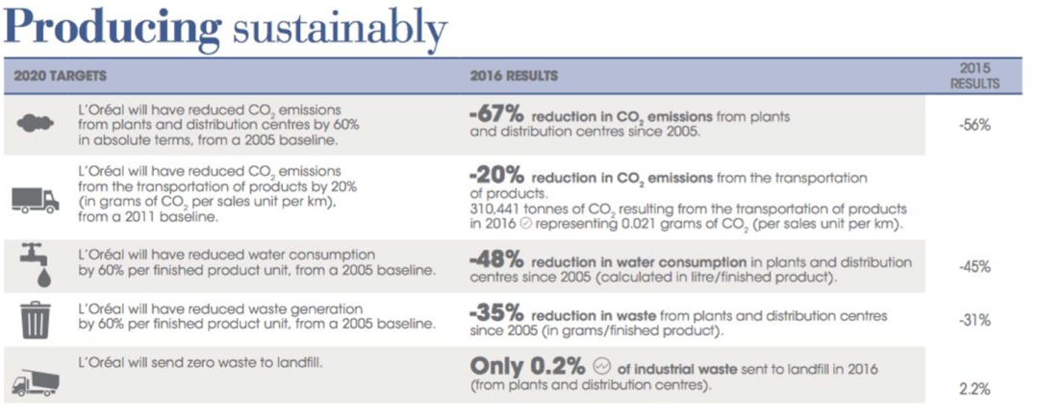

Appendix 1 (Sharingbeautywithall, 2016)

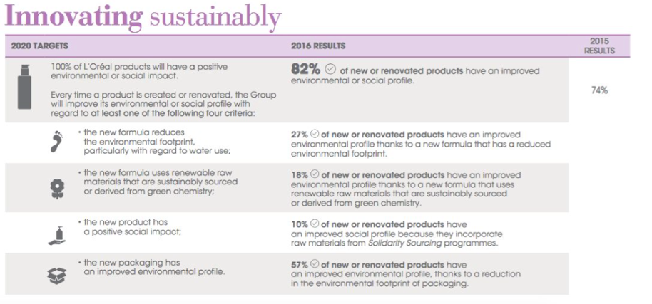

Appendix 2 (Sharingbeautywithall, 2016)

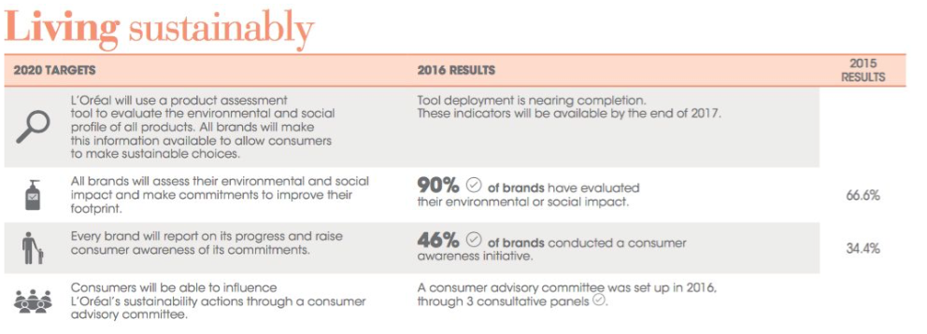

Appendix 3 (Sharingbeautywithall, 2016)

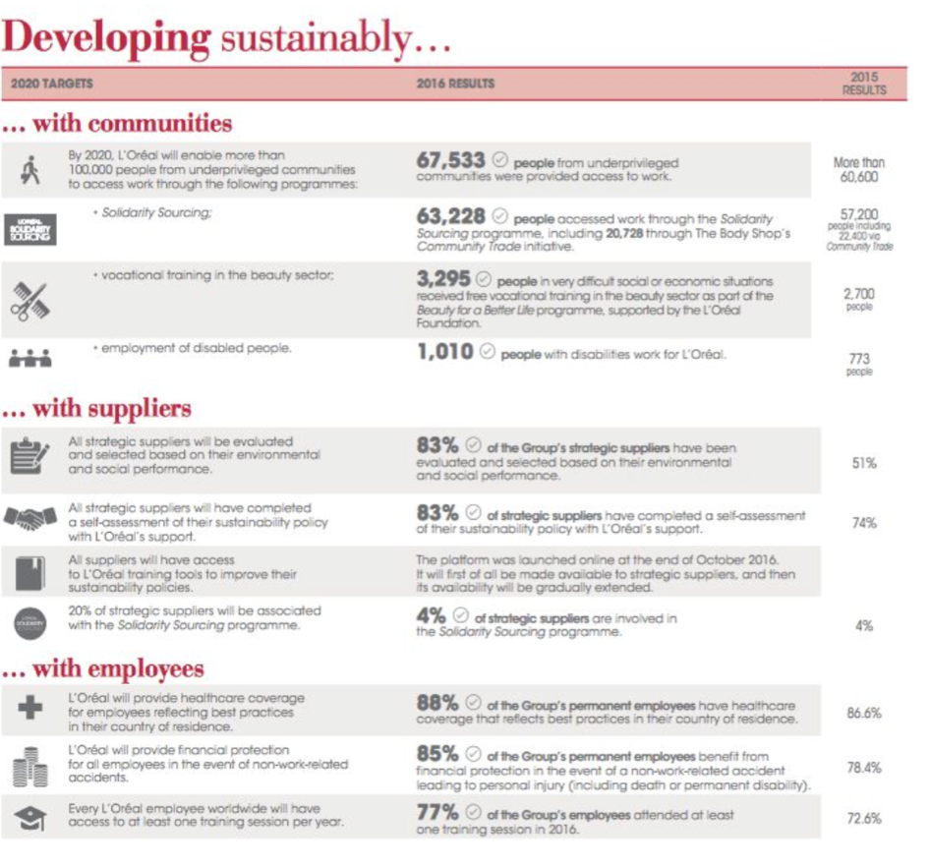

Appendix 4 (Sharingbeautywithall, 2016)

**REFERENCES**

Animals are not ours. (n.d). *L’Oreal Is Included On PETA’s “Do Test” List. What Does That Mean?* Retrieved from: <https://www.peta.org/about-peta/faq/is-loreal-cruelty-free/>

Anzilotti, E. (2017). *How L’Oréal Is Turning Itself Into A Sustainability Leader*. Retrieved from: <https://www.fastcompany.com/3069080/how-loreal-is-turning-itself-into-a-sustainability-leader>

Belch, G.E., Belch, M.A., Kerr, G. & Powel, I. (2014). *Advertising: An integrated marketing communication perspective (3e)*. North Ryde, Sydney: McGraw Hill

Bengtsen, P. & Paddison, L. (2016). *Beauty companies and the struggle to source child labour-free mica*. Retrieved from: [https://www.theguardian.com/sustainable-business/2016/jul/28/cosmetics- companies-mica-child-labour-beauty-industry-india-](https://www.theguardian.com/sustainable-business/2016/jul/28/cosmetics-%09companies-mica-child-labour-beauty-industry-india-)

Brands, S. (2016). *The Body Shop Marks 40th Year with Pledge to Be World's Most Ethical, Sustainable Global Company.* Retrieved from: [http://www.sustainablebrands.com/news and views/brand_innovation/sustainable_brands/body_shop_marks_40th_year pledge _be _worlds most_e](http://www.sustainablebrands.com/news%20and%20%09views/brand_innovation/sustainable_brands/body_shop_marks_40th_year%20pledge%20_be%20_worlds%20%09most_e)

CSRmedia. (2015). *Beiersdorf Published Its Sustainability Review 2014.* Retrieved from: <https://www.csrmedia.eu/beiersdorf-published-its-sustainability-review-2014/>

Eco-design. (2012). Retrieved from: [https://www.loreal.ca/csr-commitments/sharing-beauty-with- all/innovating-sustainably/the-new-frontiers-of-eco-design](https://www.loreal.ca/csr-commitments/sharing-beauty-with-%09all/innovating-sustainably/the-new-frontiers-of-eco-design)

Forbes. (n.d.). *133 L'Oréal Group*. Retrieved from: <https://www.forbes.com/companies/loreal-group/>

Heilpern, W. (2016). *18 False Advertising Scandals That Cost Some Brands Millions*. Retrieved from: <http://www.businessinsider.com/false-advertising-scandals-2016-3/?IR=T/#vw- falsely- advertised- environmentally-friendly-diesel-cars-1>

Investopedia. (2010). Retrieved from: <https://www.investopedia.com/terms/v/valuebasedpricing.asp>

Iqbal, N. (2017). *Munroe Bergdorf On The L’Oreal Racism Row: “It Puzzles Me That My Views Are Considered Extreme”*. Retrieved from: [https://www.theguardian.com/global/2017/sep /04/munroe- bergdorf-on-the-loreal-racism-row-it-puzzles-me-that-my-views-are-considered-extreme](https://www.theguardian.com/global/2017/sep%20/04/munroe-%09bergdorf-on-the-loreal-racism-row-it-puzzles-me-that-my-views-are-considered-extreme)

Is L’Oreal Cruelty-Free? (2017). Retrieved from: <https://logicalharmony.net/is-loreal-cruelty-free/>

Kieler, A. (2014). *Surprise! L’Oréal’s “Gene Boosting” Products Don’t Really Boost Your Genes or Make You Younger.* Retrieved from: [https://consumerist.com/2014/06/30/loreal-accused-by-ftc-of- making-false-claims-in-ads-for-age-reversing-products/](https://consumerist.com/2014/06/30/loreal-accused-by-ftc-of-%09making-false-claims-in-ads-for-age-reversing-products/)

Krazy Coupon Lady. (2016). Retrieved from: <http://thekrazycouponlady.com/tips/diy/repurpose-laundry-detergent-bottles-9-simple-disguises>

L'Oreal. (n.d.). *History*. Retrieved from: <http://www.loreal.com/group/history/1909-1956>

L’Oreal. (2017). *Research And Innovation* . Retrieved from Loreal: [http://www.loreal.com/research-and- innovation](http://www.loreal.com/research-and-%09innovation)

L'Oréal. (n.d.). *Sustainability*. Retrieved from L'Oréal: <http://www.loreal.com/sustainability>

L'Oréal. (2017). Retrieved from: <http://www.loreal.com/>

L’Oreal Sustainable. (2010). Retrieved from: [http://www.loreal.com/media/press- releases/2017/april/progress-report-2016](Http://Www.Loreal.Com/Media/Press-%09Releases/2017/April/Progress-Report-2016)

L’Oreal USA. (2017). *L’Oreal USA Recognized by EPA with Green Power Partner Of The Year Award.* Retrieved from: [https://www.prnewswire.com/news-releases/loreal-usa-recognized-by-epa-with- green-power-partner-of-the-year-award-300541265.html](https://www.prnewswire.com/news-releases/loreal-usa-recognized-by-epa-with-%09green-power-partner-of-the-year-award-300541265.html)

Marketing 91. (2004). Retrieved from: <https://www.marketing91.com/marketing-mix-loreal/>

Marketing Mix. (2002). Retrieved from: <http://sayelic92.blogspot.my/2014/08/6-marketing-mix-4ps.html>

Martin, D. & Schouten, J. (2014). *Sustainable Marketing (1st ed).* Pearson Education Limited

Mbaskool. (n.d.). *L'Oréal Marketing Mix*. Retrieved from: [https://www.mbaskool.com/marketing- mix/products/16732-loreal.html](https://www.mbaskool.com/marketing-%09mix/products/16732-loreal.html)

Naturewatch Foundation. (n.d). *L’Oreal Buys into Even More Animal Testing.* Retrieved from: <https://naturewatch.org/blog/article/loreal-buys-into-even-more-animal-testing>

Newswire, PR. (2017). *L’Oreal Redoubles the Efforts To Achieve Its Ambitious Sustainability Targets.* Retrieved from: [https://finance.yahoo.com/news/loreal-redoubles-efforts-achieve-ambitious- 030000246.html](https://finance.yahoo.com/news/loreal-redoubles-efforts-achieve-ambitious-%09030000246.html)

Nivea. (2017). Retrieved from: [https://www.nivea.co.nz/about-us/beiersdorf/Environmental- Responsibility](https://www.nivea.co.nz/about-us/beiersdorf/Environmental-%09Responsibility)

Our Commitments for 2020. (n.d). Retrieved from: [https://www.beiersdorfusa.com/sustainability/our- commitment/commitments-2020](https://www.beiersdorfusa.com/sustainability/our-%09commitment/commitments-2020)

Purkayastha, D. & Fernando, R. (2007). Retrieved from: http://backup.oikos-international.org /fileadmin/oikosinternational/international/Case_competition/Inspection_copy_ICFAI2007.pdf

Quick Guide. (2008). Retrieved from: <https://hbr.org/2016/08/a-quick-guide-to-value-based-pricing>

Recycling Guide (2013). Retrieved from: <http://www.recycling-guide.org.uk/rrr.html>

Securing the Future. (2005). Retrieved from: [https://sustainabledevelopment.un.org/content/ documents/1408uk.pdf](https://sustainabledevelopment.un.org/content/%20%09documents/1408uk.pdf)

Sharing beauty with all. (2016). *​L'Oréal*. Retrieved from: https://sharingbeautywithall.loreal. com/sites/default/files/cms/sbwa-progress-report- 2016_english.pdf.pdf

Solomon, M., Hughes, A., Chitty, B., Fripp, G., Marshall, G. &amp; Stuart, E. (2014). *Marketing 3: Real people, real choices*. Frenchs Forest: Pearson Education Australia.

Spaulding, M. (2009). *The Seven Deadly Sins of Greenwashing*. Retrieved from:

The Beauty of Responsibility. (2014). *The Estee Lauder Companies.* Retrieved from: <https://www.aveda.com/media/pdf/ELC_corp_2014.pdf>

The Body Shop. (2015). Retrieved from: [https://essayscam.org/forum/fe/body-shop-case-study- identification-corporate-social-5450/](https://essayscam.org/forum/fe/body-shop-case-study-%09identification-corporate-social-5450/)

The Guardian. (2016). *Beauty companies and the struggle to source child labour-free mica*. Retrieved from: [https://www.theguardian.com/sustainable-business/2016/jul/28/cosmetics-companies-mica- child -labour-beauty-industry-india-](https://www.theguardian.com/sustainable-business/2016/jul/28/cosmetics-companies-mica-%09child%20-labour-beauty-industry-india-)